Sumama Rahim
F24BSCS039
Database systems Lab 06 Task Report

Name | Sumama Rahim | Course | Database Systems (CSC-103) | Dprtt/ Program | IET - BSCS
Registration | F24BSCS039 | Instructor | Dr. M. Bilal Shahnawaz | Date | 04/18/2025

Lab 06 Task Report

Problem: Write a report to show the applied queries and their responses.
Solution:
Query 1: The minimum salary being paid to any faculty member.
-- Q1. the minimum salary being paid to any faculty member. --
SELECT MIN(Salary) AS 'Minimum salary'
FROM Faculty;
Response:
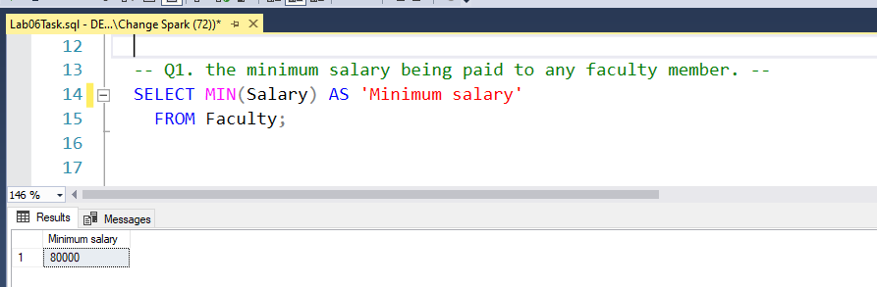
Query 2: The maximum salary being paid to any faculty member.

-- Q2. the maximum salary being paid to any faculty member. --
SELECT MAX(Salary) AS 'Maximum Salary'
FROM Faculty;
Response:
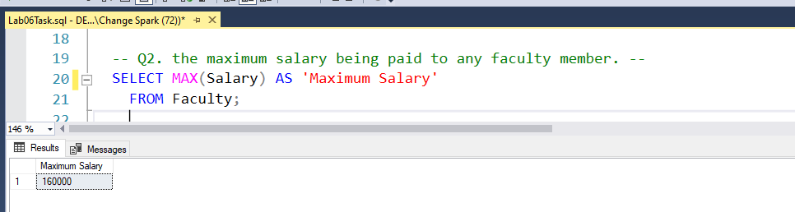

Query 3: the employee who is being paid the highest salary in the university.

-- Q3. the employee who is being paid the highest salary in the university.
SELECT *
FROM Faculty
WHERE Salary = (SELECT MAX(Salary) FROM Faculty);
Response:
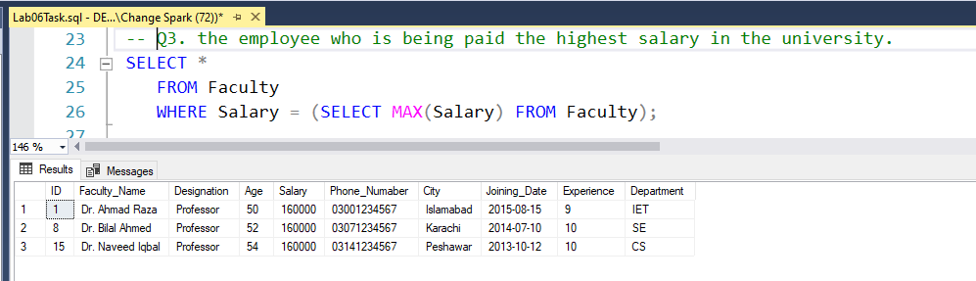
Query 4: the lecturer who is being paid the lowest salary in the CS department.
-- Q4. the lecturer who is being paid the lowest salary in the CS department.
SELECT *
FROM Faculty
WHERE Designation = 'Lecturer' AND Department = 'CS' AND Salary = (SELECT MIN(Salary) FROM Faculty);
Response:
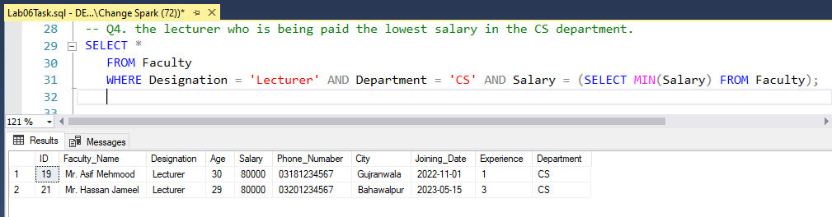
Query 5: the minimum salary being paid to any Assistant Professor.
-- Q5. the minimum salary being paid to any Assistant Professor.
SELECT *
FROM Faculty
WHERE Designation = 'Associate Professor' OR Salary > (SELECT MAX(Salary) FROM Faculty);

Response:
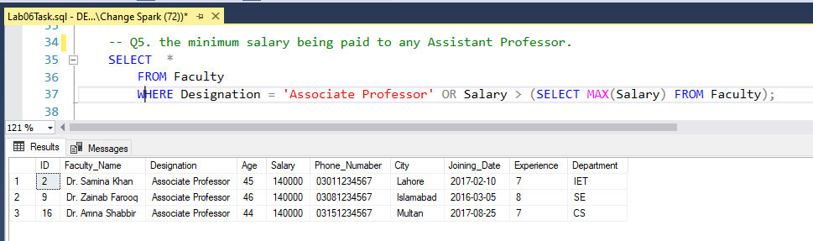
Query 6: the total number of faculty members of the university.
-- Q6. the total number of faculty members of the university.
SELECT COUNT(Designation) AS 'Total Faculty Members'
FROM Faculty;
Response:
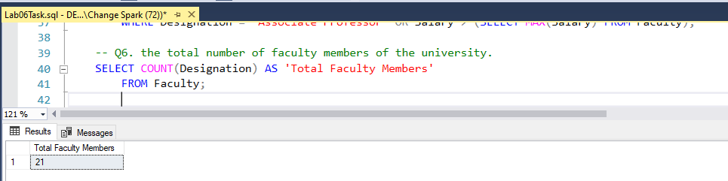
Query 7: the total number of Lecturers serving in the university.
-- Q7. the total number of Lecturers serving in the university.
SELECT COUNT(Designation) AS 'No. of Lecturers'
FROM Faculty
WHERE Designation = 'Lecturer';
Response:
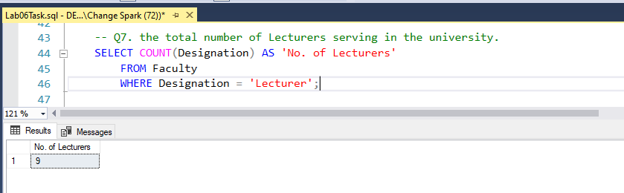
Query 8: the total number of faculty members from Islamabad.
-- Q8. the total number of faculty members from Islamabad.
SELECT *
FROM Faculty
WHERE City = 'Islamabad';
Response:
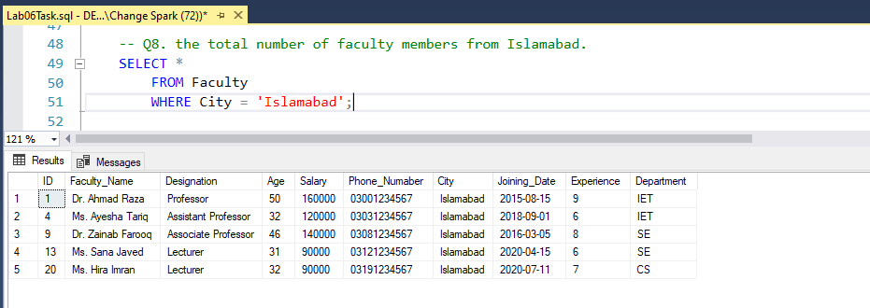
Query 9: the names of cities from which different faculty members belong.
-- Q9. the names of cities from which different faculty members belong.
SELECT DISTINCT(City)
FROM Faculty;
Response:
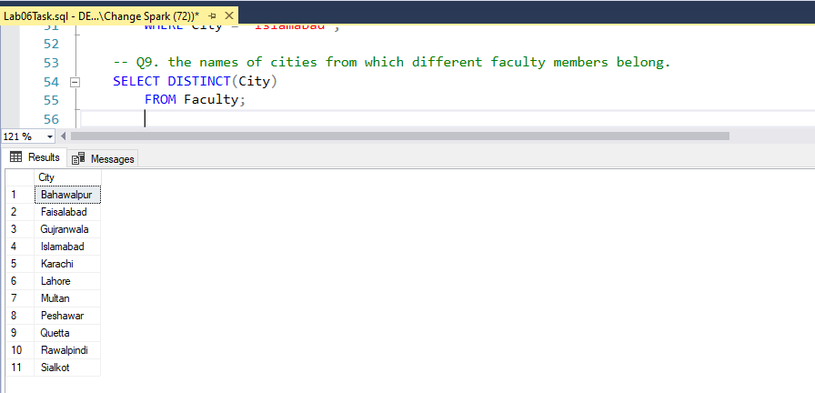
Query 10: the total amount of salary being paid to all faculty members.
-- Q10. the total amount of salary being paid to all faculty members.
SELECT SUM(Salary) AS 'Total Paid salaries'
FROM Faculty;
Response:
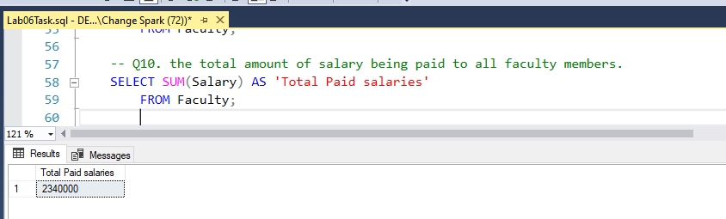
Query 11: the total salary being paid to professors of the university.
-- Q11. the total salary being paid to professors of the university.
SELECT SUM(Salary) AS 'Salary paid to all professors'
FROM Faculty
WHERE Designation = 'Professor';
Response:
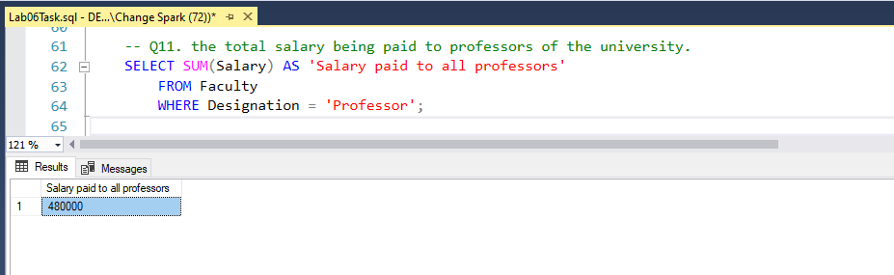

Query 12: the total salary being paid to lecturers of the IET department.
-- Q12. the total salary being paid to lecturers of the IET department.
SELECT SUM(Salary) AS 'total salary paid to IET lecturers'
FROM Faculty
WHERE Designation = 'Lecturer' AND Department = 'IET';
Response:
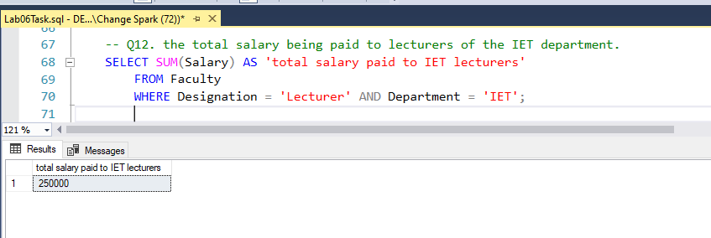
Query 13: the annual salary being paid to an Associate Professor.
-- Q13. the annual salary being paid to an Associate Professor.
SELECT Salary*12 AS 'Per annum salary of Associate Pro.'
FROM Faculty
WHERE Designation = 'Associate Professor';
Response:
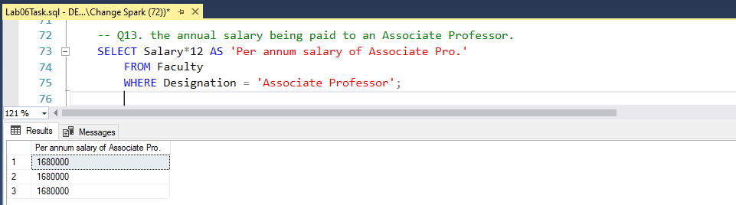

Query 14: the faculty members who are earning more than the average salary of all employees
-- Q14. the faculty members who are earning more than the average salary of all employees
SELECT *
FROM Faculty
WHERE Salary > (SELECT AVG(Salary) FROM Faculty);
Response:
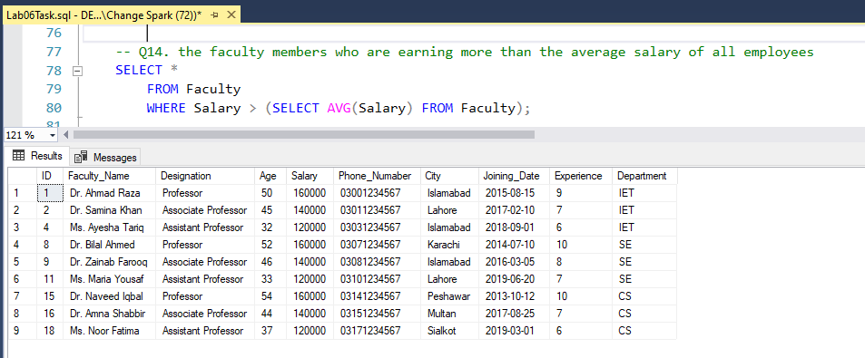
Query 15: one professor, one AP, and one lecturer joined the IET department in 2023, calculate the annual increment of the salary budget of the IET department.
-- Q15. One professor, one AP, and one lecturer joined the IET department in 2023, calculate the annual increment of the salary budget of the IET department.
SELECT SUM(Salary)*12 AS 'New Annual increment of Salary Budget of IET Department'
FROM Faculty
WHERE Department = 'IET' AND ID > 21 -- new faculty members are added

Response:
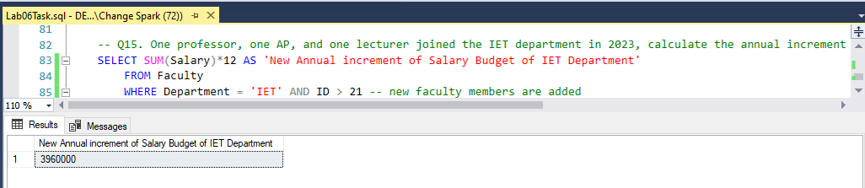
Query 16: show the faculty members and their joining date in the format "day, Month date, year" who will retire in the next 5 years if the retirement age is 60
-- Q16. Show the faculty members and their joining date in the format "day, Month date, year" who will retire in the next 5 years if the retirement age is 60
SELECT FORMAT(Joining_Date, 'dd-MM-yyyy') AS 'Joining Date', Age
FROM Faculty
WHERE Age >= 55; -- returns all, who will retire in next 5 years
Response:
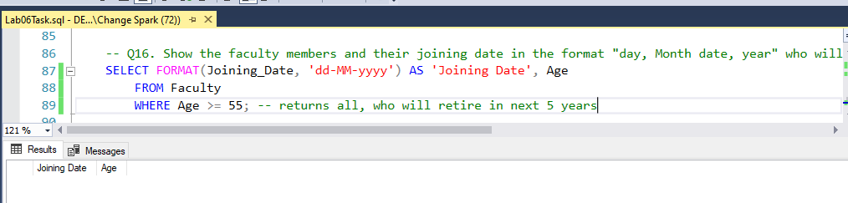
Hence, no one retires in next 5 years

THE END

